**HYDROGEN FUEL**

**AREA OF RELEVANCE :** electrical and electronics

**TYPE OF PROJECT :** fuel sourse

**ABSTRACT :** for any combustable engines may be internal ot external will need the fuel to burn and to do work on the machine.my concept is to find an easy fuel that give more combustion ratios.i am preparing the hydrogen fuel simply from the salt water which we can easily apply from sea water.through electrolysis process i can able to split up the water into hydrogen and oxygen.this hydrogen gas can be converted in to liquid state while it is taken to low temperatures such a -270 degree celsius.

**UNIQUE FEATURES :** highly combustable than petrol and diesel

**Materials used :**cycle spokes,transformer,bridge rectifier,wires,trips tube baloon,power sourse.

**DELIVERABLE :** hydrogen gas with de oxidation agent

**EXISTING APPROACH :** to increase the fuel extraction

**MY APPROACH :** new method of fuel production

**PROPOSAL DIFFERENCE ON ORIGINALITY :** absolutely the ratios are applicable for prototype with more profitable earnings.

**PERFORMANCE :** efficient to operate

**COST FOR BENIFIT :**

**APPROCHES TO SOLVE PROBLEMS :** the high pressure of hydrogen gas is applied to convert to liquid at maximum.

**MODELING :** 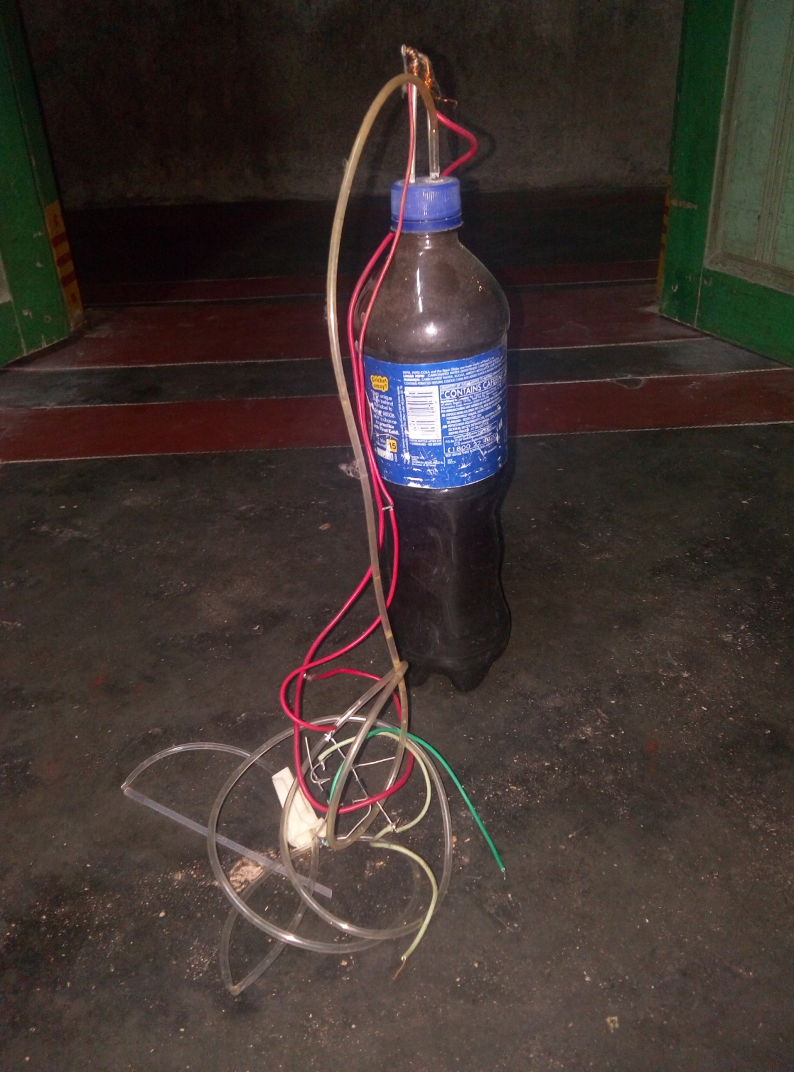

**IMPLEMENT DETAILS :**

The 230v to 12v ac stepdown transformer’s output is connected to the bridge rectifier and the outputted pulsed dc wave is supplied in to the electrodes.here the hydrogen is evolved from cathode and anode undergoes reusting.

**COMPONENTS FOR TESTING :** multimeter,match stick,soap water

**PROGRESS ON TESTING :** hydrogen gas production is directly proportional to the conductivity of water and the power supplied.

**RESULT : its our future fuel.**

**INFRASTRUTURE REQ :** planted near sea shore for beter profit.

**PROBLEMS :** water is poluted but recycled.

**DIS ADVANTAGES :** needs electricity

**RESEARCH** : on fuels and combustions.

**BUDGET ESTIMATE** : 550 rs for my model.

**CONCLUSION :** we can use it for engines and gas welding too.